Product Data Sheet
KAVACH 4520 (NR) is an ultra-bright fluorescent magnetic particle powder for locating small, medium, and large discontinuities. These particles provide clear, ultra-bright, fluorescent green indications under UV light with minimal background. KAVACH 4520 (NR) is designed for use in water baths for wet method fluorescent magnetic particle testing. It has parent material of KAVACH 470 & water conditioner KAVACH WA 11 in much finer and dry forms.
PROPERTIES
Appearance | Fine, dry powder
Color in Visible  Light | Green
Color in UV Light | Fluorescent yellow-green
Odor | Odorless
Mean Particle Size* | 6-8 microns
SAE Sensitivity | 7
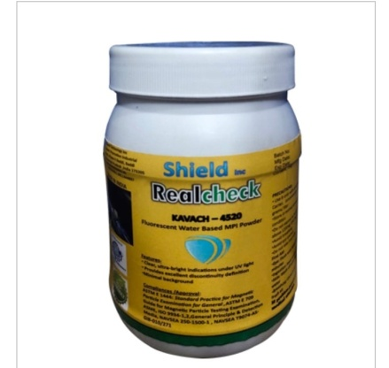
Approval/Confirmation to: KAVACH 4520(NR)
- NAVSEA 250-1500-1 Available in 1 Kg Packing
- ASTM E 1444
- ASTM D 445
- ASTM E 709
- ASME
- ISO-3944-1
Preparatory Instruction:
Weigh out the appropriate amount of KAVACH 4520 (NR) and add to the appropriate amount of water vehicle. Mix for a minimum of 15 minutes, until the particles are completely and evenly dispersed in the suspension. Check concentration before use.
Mixing Ratio: 10.75 Gms/Lit
Instruction to use:
Use water media with appropriate magnetization procedure and equipment. For best results, all components, parts, or areas to be tested should be clean and dry prior to testing to provide an optimal test surface and reduce particle suspension contamination. Particle suspension must be properly mixed and continuously agitated when in use to ensure uniformity and concentration.
Note: The given data is best known to our knowledge, however if any discrepancy found in given data will be liable only for replacement.

